CONSUMER BEHAVIOR ANALYTICS

Project Introduction
Consumer behavior analytics help businesses understand how consumers differ in their demographics, purchase habits, channel usage, and responses to marketing efforts. Instead of treating all consumers the same way, a company can use data to identify valuable customer groups, understand purchasing patterns, and design more effective promotional strategies. In the GourmetHub Market case, the available dataset includes consumer demographics, household characteristics, product spending, web activity, purchase channels, and previous campaign outcomes. This makes it possible to study both historical consumer behavior and campaign effectiveness in an integrated way.
This project applies both unsupervised and supervised analytics to support marketing decisions. Multiple machine learning techniques are implemented to perform consumer segmentation, campaign acceptance behavior analysis, consumer engagement analysis and predict the likelihood of campaign acceptance. The final goal is to turn these analytical results into practical recommendations that improve targeting, engagement, conversion, and revenue for the business.

Business and Analytical Goals

Business Goal
The business goal of this project is to help GourmetHub improve its marketing effectiveness by understanding its consumers more clearly and using that understanding to make better targeting decisions. The company wants to identify meaningful consumer groups, learn which groups are more responsive to promotions, understand which historical behaviors are associated with campaign success, and predict future engagement and response. By doing this, GourmetHub can avoid sending the same campaign to all consumers and instead use more focused strategies that improve conversion and marketing efficiency. This direction results in segmenting consumers, analyzing campaign effectiveness, and recommending practical targeting and channel strategies.
Analytical Goal
The analytical goal of this project is to use both unsupervised and supervised models on the dataset to support better marketing decisions.
Consumer Segmentation:
Create consumer segments to groups customers based on their demographics and spending behavior. And use these segments to analyze the segments and their significance in campaign response.
Campaign Acceptance Behavior analysis:
Apply association analysis identify useful rules among previous campaign acceptance variables and the customer spending and purchase behavior variables.
Campaign Engagement Prediction:
Build a regression model to understand the consumer transaction activity and the factors influencing it using Total_Purchases as a measure of engagement.
Classification of Campaign Response:
Develop classification models to predict whether a consumer will respond positively to a marketing campaign
Evaluate model performance and compare results to select the most effective approaches
Translate analytical findings into actionable business insights for targeted marketing, campaign optimization, and resource allocation.

Data preprocessing
The Dataset provided has a total of 2240 records and 29 columns. There are no duplicate records detected in the dataset.
Attribute Definition:
The 29 columns include the consumer’s demographics, spending history, campaign acceptance. Summary statistics are used to analyze the range and distribution of these variables.
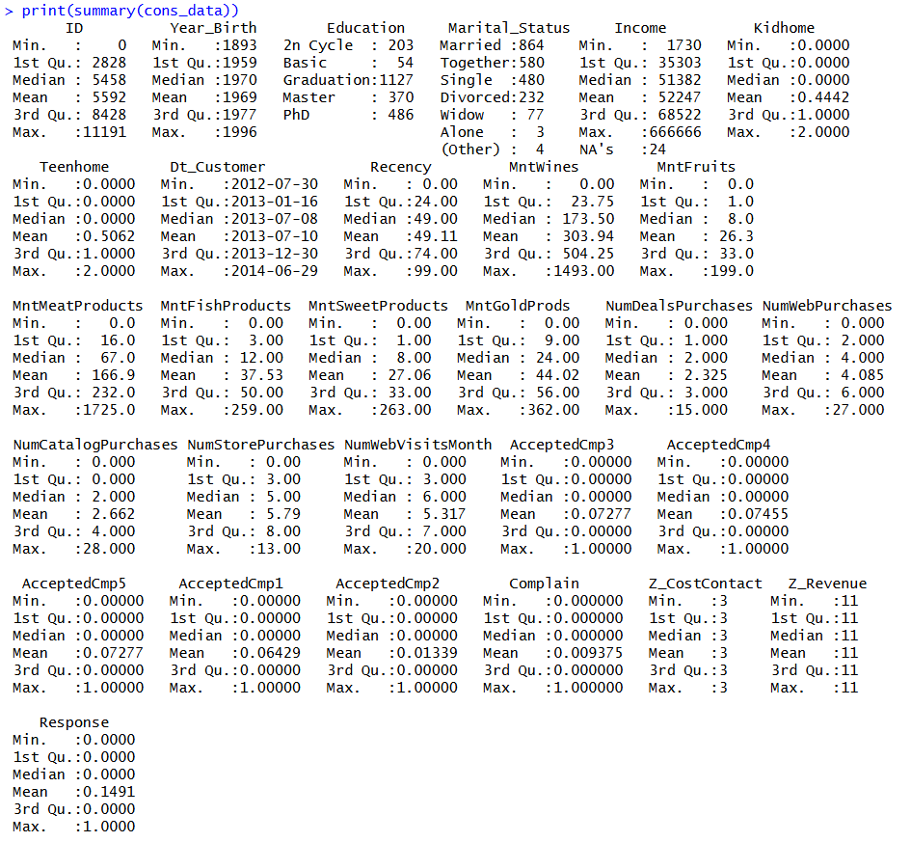
- ID:
ID is the unique customer ID used to identify the customers.
Demographic variables:
- Year_Birth:
Represents the birth year of the consumer. Values range from 1893 to 1996, with a median of 1970 and mean of 1969, indicating most consumers are middle-aged, with a few extreme older values (outliers).
- Education:
Categorical variable representing education level. The majority of consumers belong to Graduation (1,127), followed by PhD (486) and Master (370), while Basic (54) has the lowest representation.
- Marital_Status:
Categorical variable describing relationship status. Most consumers are Married (864), followed by Together (580) and Single (480), with smaller categories like Widow, Alone, and Others.
- Income:
Annual household income of consumers. Values range from 1,730 to 666,666, with a mean of 52,247 and median of 51,382. The large maximum value indicates right-skewness and presence of outliers. There are 24 missing values.
- Kidhome:
Number of children in the household. Values range from 0 to 2, with a mean of 0.44, indicating most households have no or one child.
- Teenhome:
Number of teenagers in the household. Values range from 0 to 2, with a mean of 0.51, showing similar distribution to Kidhome.
Behavioral variables:
- Dt_Customer:
Date of customer enrollment. Values range from 2012-07-30 to 2014-06-29, indicating customer acquisition over a two-year period.
- Recency:
Number of days since last purchase. Values range from 0 to 99, with a mean of 49.11, suggesting moderate engagement with variability across customers.
- MntWines:
Amount spent on wine. Values range from 0 to 1,493, with a mean of 303.94 and median of 173.50, indicating high variability and right-skewness.
- MntFruits:
Spending on fruits ranges from 0 to 199, with a mean of 26.3, indicating relatively low spending compared to other categories.
- MntMeatProducts:
Spending ranges from 0 to 1,725, with a mean of 166.9, showing strong contribution to total spending.
- MntFishProducts:
Values range from 0 to 259, with a mean of 37.53, indicating moderate spending.
- MntSweetProducts:
Values range from 0 to 263, with a mean of 27.06, similar to fruit spending.
- MntGoldProds:
Spending ranges from 0 to 362, with a mean of 44.02, indicating occasional high-value purchases.
- NumDealsPurchases:
Number of purchases made using deals. Values range from 0 to 15, with a mean of 2.33, indicating moderate usage of discounts.
- NumWebPurchases:
Online purchases range from 0 to 27, with a mean of 4.09, showing active digital engagement.
- NumCatalogPurchases:
Values range from 0 to 28, with a mean of 2.66, indicating lower usage compared to other channels.
- NumStorePurchases:
Store purchases range from 0 to 13, with a mean of 5.79, making it the most used purchase channel.
- NumWebVisitsMonth:
Website visits range from 0 to 20, with a mean of 5.32, indicating varying levels of online engagement.
Campaign variables:
- AcceptedCmp1 - AcceptedCmp5:
Binary variables indicating acceptance of previous campaigns. Means range from 1.3% to 7.4%, showing low campaign success rates.
- Complain:
Indicates whether the customer complained. Mean value is 0.009, meaning complaints are very rare.
- Z_CostContact:
Constant value of 3 across all observations, representing standardized contact cost.
- Z_Revenue:
Constant value of 11, representing standardized revenue from contact.
- Response:
Target variable indicating acceptance of the latest campaign. Values are binary (0/1), with a mean of 0.149, meaning 14.91% of customers responded positively, indicating low conversion rate.
Exploratory Data Analysis:
This set of data comprises 2,240 customers with various demographic attributes and purchase behavior. From initial investigation, there is a considerable amount of diversity regarding consumers' income levels, purchases, and transactions. A thorough EDA is conducted to analyze the spending patterns across the demographics.
First of all, income is highly dispersed with a minimum value of 1,730 and maximum value of 666,666. The average value is about 52,247. Thus, one can conclude that the consumer group has some consumers with higher income levels. High levels of income have an impact on consumer behavior. In other words, those with high income make more purchases, which is proved by the results provided in further investigation.
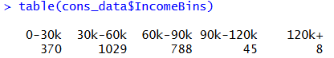
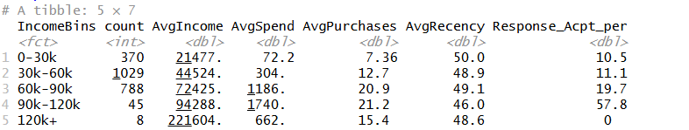
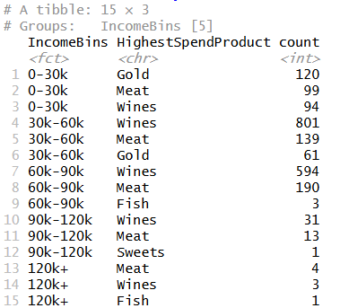
Income-based analysis shows a clear relationship between income level and consumer behavior. The majority of customers fall in the 30k–60k (1,029) and 60k–90k (788) income groups, while very high-income customers (120k+) are very few (8), indicating a skewed distribution. As income increases, both spending and purchase activity increase significantly. For example, average spending rises from 72.2 in the 0–30k group to 1,186 in the 60k–90k group and further to 1,740 in the 90k–120k group, while average purchases also increase from 7.36 to over 21 transactions. Campaign response rates also improve with income, reaching 57.8% in the 90k–120k group, compared to around 10–11% in lower income groups, suggesting that higher-income customers are more responsive to marketing efforts.
Product preference also varies across income segments. Lower-income consumers (0–30k) show higher preference for Gold products (120), followed by Meat and Wines, whereas middle and higher-income groups consistently show Wines as the dominant product category (e.g., 801 in 30k–60k and 594 in 60k–90k), followed by Meat. This indicates that as income increases, consumers shift toward premium categories such as wine, while lower-income groups exhibit relatively different spending preferences.

Regarding consumer spending on different product categories, one can see distinct differences. For example, wine represents the category which is characterized by the highest expenditure – 680,816; the second one is meat products – 373,968. Other categories include gold (98,609); fish (84,057); sweets (60,621); and fruits (58,917). As can be seen, people invest more money in the purchase of wine and meat products than in others.
Transaction behavior on different channels provides more insight into the findings. Transactions from stores are the highest at 12,970 transactions. The second highest transaction behavior is from web purchases at 9,150 transactions. Catalog and deal purchases have fewer transactions at 5,963 and 5,208 transactions respectively. This means that even though online channels are essential, physical store purchases are still the dominant channel where transactions occur. Web visits stand at 11,909, meaning that not all online interactions result in transaction behavior.
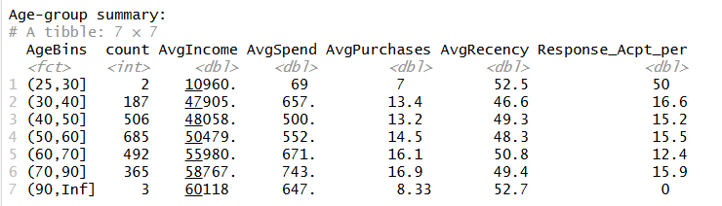

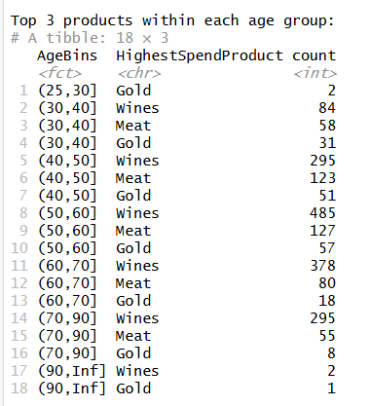
The age distribution shows that most customers fall in the middle to older age groups, with the highest number in the 50–60 range (685), followed by 40–50 (506) and 60–70 (492). The 70–90 group also has a significant count (365), while very few customers are below 30 or above 90. Income and spending increase with age, where the 70–90 group has the highest average income (58,767) and spending (743), followed by the 60–70 group. Purchasing activity also increases with age, with the 70–90 group showing the highest average purchases (16.9). However, campaign response rates remain relatively similar across age groups, mostly between 12% and 16%.
Product preferences are consistent across all age groups, with wines being the most dominant category, followed by meat and gold products. For example, in the 40–50 group, wines are the top product for 295 customers, compared to 123 for meat and 51 for gold. Similar patterns are seen in other groups such as 50–60 and 70–90, where wines consistently lead. This shows that customer preferences remain stable across age segments, with wine as the primary spending category and meat and gold as secondary choices.
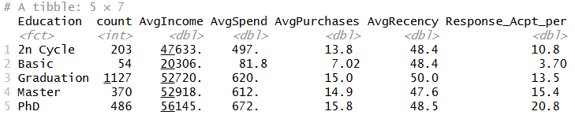
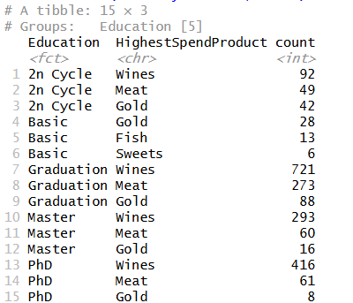
From the analysis of education-level spending, it was evident that individuals with high education levels, such as PhD and Masters, have relatively higher incomes (56,145 and 52,918), respectively. Additionally, the spending of these two consumers was much higher (672 and 612), respectively. On the contrary, those with a basic education level had low incomes (20,306) and lower spending (81.8).

Preference for product in various categories of education is an additional evidence of the leading position occupied by wine among the purchases made by the consumers. For instance, wine dominates (721) among graduates, second is meat (273) and third is gold (88). The same situation is observed among consumers with PhD level of education where wine leads (416), and second is meat (61). On the contrary, among consumers with basic level of education, gold dominates (28) and fish comes second (13).
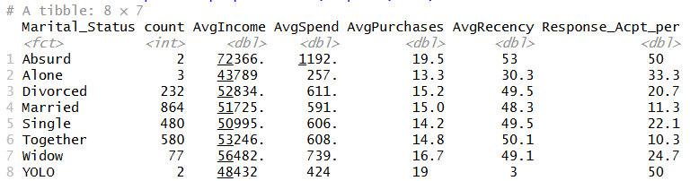
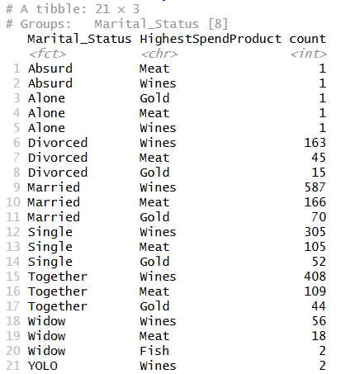
Marital status of the respondents also has a great influence on their buying behavior. Consumers, who are married, make up the largest proportion (864) but with a moderate spending (591) and purchase (15.0) rate. Widowed consumers spend more money (739) and buy more frequently (16.7). Consumers, who are divorced and single, tend to respond at a higher rate. Preference of the product in terms of marital status demonstrates once again wine's leading position. Among married consumers, the leading position is occupied by wine (587), second is meat (166).
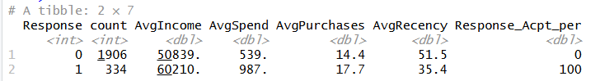
Campaign response behavior shows that only 14.91% of consumers accepted the most recent campaign, indicating a relatively low conversion rate. However, customers who responded positively have significantly higher income (60,210 compared to 50,839), higher spending (987 compared to 539), higher purchase frequency (17.7 compared to 14.4), and lower recency (35.4 compared to 51.5). This indicates that more engaged and higher-value customers are more likely to respond to marketing campaigns.

Correlation Analysis:
Correlation analysis was performed to understand the relationships between key demographic, behavioral, spending, and campaign variables.
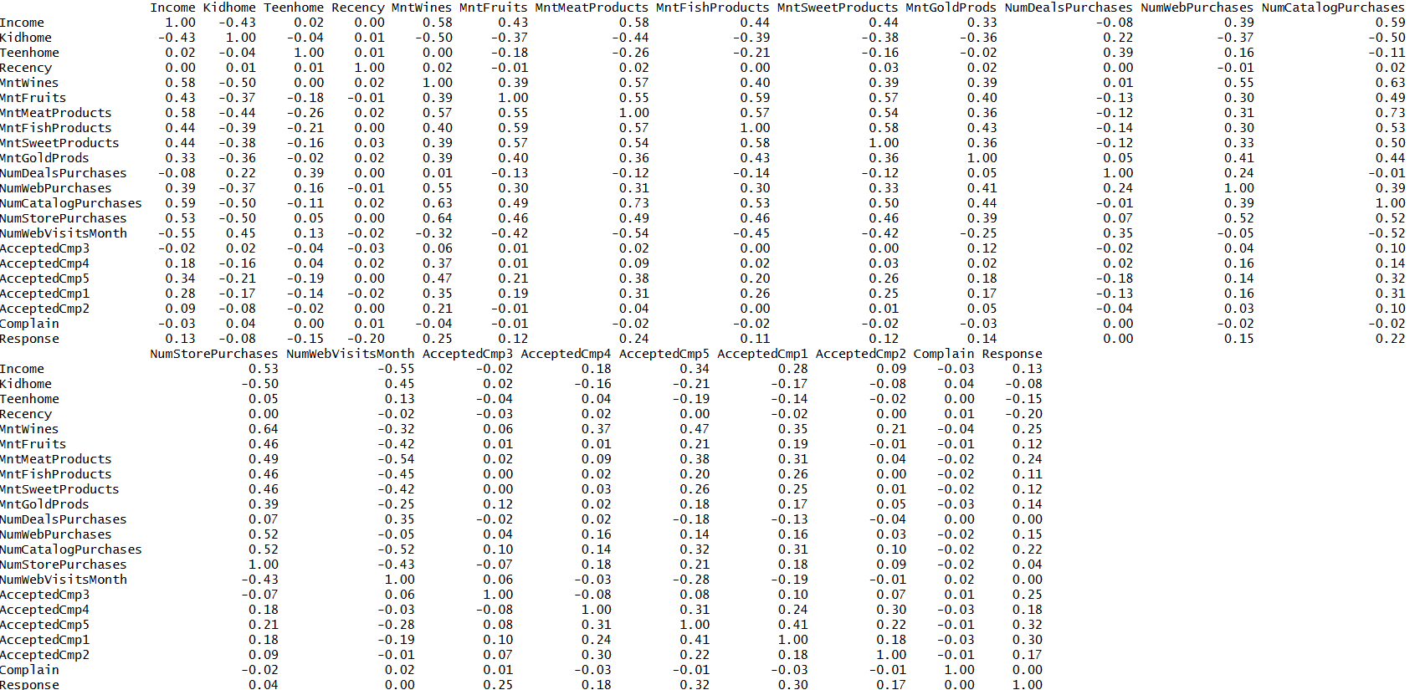
The results show a strong positive relationship between Income and spending variables, particularly with MntWines (0.58), MntMeatProducts (0.58), and NumCatalogPurchases (0.59), indicating that higher-income consumers tend to spend more and engage more in purchasing activities. Income also shows a moderate positive correlation with NumStorePurchases (0.53), further confirming that higher-income customers are more active buyers. In contrast, Income has a strong negative correlation with NumWebVisitsMonth (-0.55), suggesting that higher-income consumers rely less on website visits and possibly make more direct or planned purchases.
Spending variables are highly correlated with each other, such as MntWines and MntMeatProducts (0.57), MntFruits and MntFishProducts (0.59), and MntFishProducts and MntSweetProducts (0.58). These strong relationships indicate that consumers who spend more in one category are likely to spend more in others, confirming redundancy among spending variables.
Household variables show notable patterns. Kidhome has a strong negative correlation with Income (-0.43) and spending variables (e.g., -0.50 with MntWines), indicating that households with children tend to have lower income and lower spending. Teenhome shows weaker but still negative relationships with spending variables, suggesting a similar but less pronounced effect.
Recency shows very weak correlation with most variables but has a negative correlation with Response (-0.20), indicating that customers who purchased more recently are more likely to respond to campaigns.
Purchase behavior variables also show meaningful relationships. NumCatalogPurchases has a strong positive correlation with MntMeatProducts (0.73) and MntWines (0.63), suggesting that catalog buyers tend to spend more. NumWebPurchases and NumStorePurchases also show moderate positive relationships with spending variables, confirming that higher spending is associated with higher purchase frequency.
Campaign-related variables show moderate positive relationships with spending and income. For example, AcceptedCmp5 is positively correlated with Income (0.34), MntWines (0.47), and Response (0.32), indicating that customers who responded to previous campaigns are more likely to respond again. Similarly, AcceptedCmp1 shows a correlation of 0.30 with Response.
Finally, the Response variable shows positive correlations with Income (0.13), MntWines (0.25), MntMeatProducts (0.24), and NumCatalogPurchases (0.22), indicating that higher-value and more active customers are more likely to accept campaigns. Recency shows a negative relationship (-0.20), reinforcing that recently active customers are more responsive.
Overall, the correlation analysis highlights strong relationships between income, spending, and purchasing behavior, as well as the importance of past campaign acceptance in predicting future responses.
Handling Missing Values:
The dataset was checked for missing data, and it was observed that only Income had missing values, which were a total of 24 observations, while all other variables had no missing data.
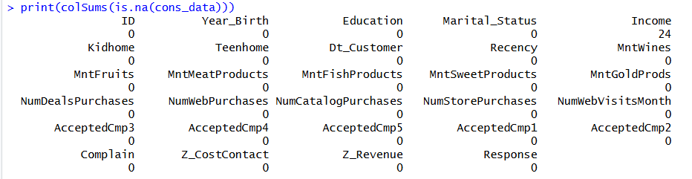
Due to its importance in predicting consumer behavior, care was taken not to delete these missing values as it would have decreased the size of our data, thus affecting analysis. Therefore, the median income, which was approximately 51,382, was used to replace the missing values rather than deleting them. Imputation through the use of the median rather than the mean was preferred since the distribution of the variable is positively skewed, with some extremely high outliers.

Predictor analysis and relevancy
Variable selection was done in accordance with the objective of each of the tasks, ensuring that only meaningful predictor variables would be used without causing data leakage or any redundancies.
Consumer Segmentation:
While doing segmentation of consumers, only demographic and behavioral variables were chosen.
Variables used:
Demographics: Income, Age, Education, Marital_Status, Kidhome, Teenhome
Behavioral: Recency, NumDealsPurchases, NumWebPurchases, NumCatalogPurchases, NumStorePurchases, NumWebVisitsMonth
Spending (via PCA): MntWines, MntFruits, MntMeatProducts, MntFishProducts, MntSweetProducts, MntGoldProds (transformed into PCA components)
The predictor variables that relate to campaigns, like AcceptdCmp1–5 and Response, were not included here as the aim is to group consumers purely based on their behaviors without being influenced by campaigns in any way. Thus, unbiased segments of consumers can be determined through these variables.
Campaign Behavior Analysis:
In analyzing the behavior of a campaign, goal is to study how the previous behavior of campaigns can affect acceptance to looking at how the purchasing behavior of consumers affects campaigns. Besides the past variables of campaigns, the behavior of the product itself and the behavior of purchases is also included.
Variables used:
Product behavior (converted to binary): Buy_Wine, Buy_Meat, Buy_Fish, Buy_Sweet, Buy_Fruit, Buy_Gold
Purchase behavior (converted to binary or categories): NumDealsPurchases, NumWebPurchases, NumCatalogPurchases, NumStorePurchases
Campaign outcome variables: AcceptedCmp1, AcceptedCmp2, AcceptedCmp3, AcceptedCmp4, AcceptedCmp5
Here, the expenditure variables are first converted into binary variables that indicate if there was any purchase of a given category of product by the consumer. Likewise, the transactional data variables are represented using binary to indicate any purchasing done via various sales channels. These variables are combined with the campaign variables to produce transactional-like data.
The association is used on this generated data to come up with association rules. Such association rules help to identify, for instance, combinations of products and sale channels that have a correlation with acceptance of campaigns. The generated association rules thus give an idea about the consumers whose purchasing pattern makes them susceptible to campaigns.
Regression Analysis:
The variables used for the regression analysis model to understand consumer behavior, Total Purchases, include demographic and behavior variables, expenditure-related variables. This is because the variables would determine the purchase behavior of consumers. The reason is that people with more income will make frequent purchases, while those who spend more money will engage in purchasing activities.
Target variable:
TotalPurchases
Predictor variables:
Income
Age
Recency
Kidhome, Teenhome
Spending variables (or PCA components)
Some of these variables can be removed to improve the model which will be determined at the modeling phase.
Classification Model (Predicting Response):
A new response variable is created to capture the positive response to campaigns. The new variable describes whether a consumer responded to any previous campaigns, ensuring consistency and stability in measuring customers’ reactions to marketing initiatives.
For classification modeling, the aim is to identify consumers who are responsive to campaigns in terms of their demographics and behaviors. The analysis of the relationships among predictor variables reveals that the Income, TotalSpend, and TotalPurchases variables are positively correlated with the response to campaigns, whereas Recency is negatively correlated.
Target variable:
Response to any campaign
Predictor variables:
Demographics: Income, Age, Education, Marital_Status, Kidhome, Teenhome
Behavioral: Recency
Spending: PCA components (or Mnt* variables)
Purchase behavior: NumWebPurchases, NumStorePurchases, NumCatalogPurchases, NumDealsPurchases

Dimension reduction
In this dataset, there are several independent variables regarding expenditure (MntWines, MntFruits, MntMeatProducts, MntFishProducts, MntSweetProducts, and MntGoldProds) that are strongly related to each other and measure similar things about consumer behavior regarding purchases. In order to remove redundant data, Principal Component Analysis (PCA) was performed on these independent variables after normalizing them.
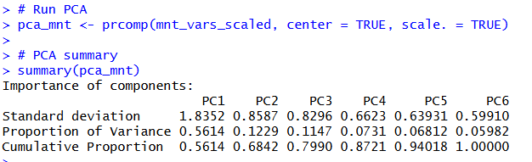
According to the findings from the PCA, the first component (PC1) accounts for 56.14% of the total variation, which means that a considerable amount of consumer purchase behavior can be explained by one component. Furthermore, PC2 and PC3 account for 12.29% and 11.47% of the total variation, respectively. In sum, the first three principal components account for around 79.9% of the total variation, which is enough to cover most information from the original independent variables.
The scree plot further supports this observation, showing a sharp decline in variance after the first component and a noticeable leveling off after the third component. This indicates that additional components contribute relatively little new information and can be excluded without significant loss of explanatory power.
Based on these results, the first three principal components were selected for further analysis. These components provide a compact and uncorrelated representation of consumer spending patterns, reducing multicollinearity and improving the stability of subsequent models. The reduced components were then used as inputs for clustering and other analytical models, ensuring that segmentation is driven by meaningful and non-redundant behavioral patterns.
Overall, PCA effectively simplifies the spending variables while preserving most of the underlying variation, making it an appropriate technique for dimensionality reduction in this analysis.

Data engineering and transformation
After data preprocessing and dimension reduction, the dataset was transformed into model-ready form. This step was important because the project uses segmentation, association analysis, regression, and classification, and each method needs the data in a suitable structure.

First, the consumer age variable was created from Year_Birth. This made the variable easier to understand than using birth year directly. The output shows that age ranged from 30 to 133, with a mean age of 57.19 and a median age of 56. This transformed variable was later used in clustering, regression, and classification because age is more meaningful for customer behavior analysis than birth year.
Next, missing income values were handled through imputation. The dataset had 24 missing values in Income, while all other variables had no missing values. Since income is important for understanding spending and campaign behavior, the missing records were not removed. Instead, the median income was used because income was right-skewed and had extreme values. In the training data, the median income used for imputation was 50,737. After imputation, both training and testing data had zero missing income values.
New summary variables were also created to make consumer behavior easier to model. TotalSpend was created by adding all product spending variables, including wine, fruits, meat, fish, sweets, and gold products. This variable gives one overall measure of customer spending value. TotalPurchases was created by combining purchase activity across channels such as deals, web, catalog, and store purchases. This variable was used as the target for the regression model because it represents consumer transaction activity and marketing engagement.
For classification, a new target variable called AcceptedAny was created. This variable identifies whether a customer accepted at least one previous campaign. This was more stable for modeling than looking at only one campaign response because previous campaign acceptance rates were low. The output shows that 463 customers accepted at least one campaign and 1,777 did not. This means about 20.67% of customers were positive responders, while about 79.33% were non-responders.
Categorical variables were transformed into dummy variables so they could be used in machine learning models. Variables such as Education and Marital_Status were converted into separate numeric indicators. This was necessary because clustering, regression, logistic regression, decision tree, and random forest models require categorical values to be represented in a model-friendly format. After dummy variable creation for clustering, the dataset had 1,568 training records and 22 variables before PCA components were added.
The spending variables were also transformed using PCA. The six product spending variables were highly related, so using all of them directly could create redundancy. PCA reduced these six spending variables into three principal components. The first three components explained about 80.25% of the total spending variation, with PC1 explaining 55.97%, PC2 explaining 12.73%, and PC3 explaining 11.55%. These three components were then added to the clustering data, increasing the clustering dataset from 22 to 25 variables.
For association analysis, the data was transformed into transaction-style variables. Product spending variables were converted into binary purchase indicators such as whether the customer bought wine, meat, fish, sweets, fruits, or gold products. Purchase channel variables were also converted into buyer indicators such as web buyer, catalog buyer, store buyer, and deal buyer. This transformation was needed because association rules work better with yes/no item-style data rather than raw numeric spending values.
Overall, the data engineering process converted the raw consumer dataset into meaningful modeling inputs. Age, total spending, total purchases, campaign acceptance, dummy variables, PCA components, and binary transaction indicators helped align the data with the project goals. These transformations made the data suitable for segmentation, campaign behavior analysis, engagement prediction, and campaign response classification without introducing future-step information into this section.

Data partitioning methods
To evaluate model performance effectively, the dataset was split into training and testing sets. A stratified sampling approach was used to ensure that the distribution of the target variable (AcceptedAny) remained consistent across both datasets. This helps in avoiding bias during model evaluation.
The dataset was divided into 70% training data and 30% testing data. The training dataset contained 1,568 observations, while the testing dataset contained 672 observations.
The distribution of the target variable was carefully checked before and after splitting. Before the split, approximately 79% of customers had not accepted any campaign, while around 21% had accepted at least one campaign. After partitioning, both training and testing datasets maintained a similar distribution, ensuring consistency and reliability in model evaluation.
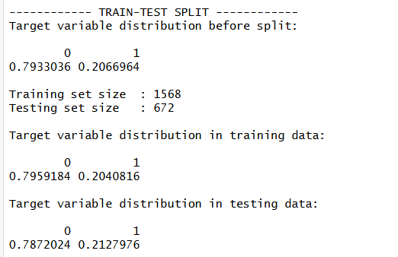
Since the dataset exhibited class imbalance, with fewer customers responding to campaigns, additional preprocessing was performed during the modeling phase. The ROSE (Random Over-Sampling Examples) technique was applied to the training dataset to create a balanced dataset for classification models. This step improves the model’s ability to correctly identify customers who are likely to respond to campaigns.
All transformations such as income imputation, PCA scaling, and standardization were performed using the training dataset and then applied to the testing dataset. This approach avoids data leakage and ensures that model evaluation reflects real-world performance.
Overall, the data partitioning strategy ensures that the models are trained on representative data and evaluated on unseen data, leading to reliable and unbiased performance assessment.

Model selection
The models used in this project were selected based on the specific business objectives of understanding customer behavior, identifying segments, and improving campaign targeting. The selection is aligned with the actual data processing and modeling steps implemented in the R workflow.
For customer segmentation, the K-means clustering model was used. The model grouped customers based on demographic, behavioral, and transaction-related variables along with PCA-transformed spending features. The optimal number of clusters was determined using the elbow method by evaluating within-cluster sum of squares for different values of k. Based on this, k = 4 was selected. The clustering quality was further validated using a silhouette score of approximately 0.53, indicating reasonable separation between clusters. This model helps in identifying distinct customer groups for targeted marketing strategies.
To validate whether the clusters are meaningful, statistical testing was performed. ANOVA was used to test differences in income across clusters, and chi-square tests were used to examine relationships between clusters and categorical variables such as education and campaign response. The results showed statistically significant differences, confirming that the clusters are meaningful and useful for business decisions.
For campaign behavior analysis, the Apriori association rule model was selected. This model identifies patterns between customer purchase behavior and campaign acceptance. The dataset was transformed into transactional format with binary variables such as product purchases and channel usage. The model initially generated over 5,000 rules, which were then filtered to obtain a smaller set of strong and interpretable rules. These rules highlight combinations such as web and catalog buyers having a higher likelihood of campaign acceptance. This approach supports targeted campaign design based on observed behavioral patterns.
For customer engagement understading, a linear regression model was used with TotalPurchases as the target variable. A full model including all predictors was first built, followed by stepwise regression to simplify the model and improve interpretability. The final model retained key variables.
For campaign response prediction, multiple classification models were implemented and compared such as Logistic regression, Decision Tree an Random Forest. The training data was balanced using the ROSE technique to address class imbalance before model building. Model evaluation was conducted using confusion matrix metrics and AUC values, allowing comparison of performance across models.
Overall, the model selection covers segmentation (K-means), pattern discovery (Apriori), engagement prediction (regression), and response prediction (classification). Each model was chosen based on its suitability for the analytical task and its ability to provide actionable insights for improving marketing strategies.

Model fitting, validation accuracy and test accuracy
All models were trained on the training dataset and evaluated on the testing dataset to understand how well they perform on new customer data.
Clustering Analysis:
The K-means clustering model was fitted on the training dataset using 4 clusters. The number of clusters was selected using the elbow method by evaluating within-cluster sum of squares (WSS) for k values from 2 to 10. The WSS values decreased from 228,840,953,745 at k = 2 to 87,264,851,238 at k = 4.
The final model produced 4 clusters with sizes 360, 456, 267, and 485. The average silhouette width for the clustering model was 0.5291716.
ANOVA was performed to test differences in income across clusters, resulting in an F-value of 3756 with a p-value less than 0.05.
Chi-square test for cluster and education resulted in X-squared value of 174.42 with p-value less than 0.05. Chi-square test for cluster and AcceptedAny resulted in X-squared value of 207.6 with p-value less than 0.05.
The average response rate (AcceptedAny) across clusters was:
Cluster 1: 8.33%
Cluster 2: 18.86%
Cluster 3: 51.69%
Cluster 4: 13.61%
Association Analysis:
The Apriori model was first fitted with support = 0.01 and confidence = 0.30. This generated 5,325 rules.
A refined Apriori model was then fitted with support = 0.005, confidence = 0.20, minimum rule length = 2, and maximum rule length = 3. This resulted in 26 rules after removing redundant rules.
Example rules include:
{Web_Buyer = Yes, Catalog_Buyer = Yes} → {AcceptedAny = Yes}
Support: 0.1639
Confidence: 0.3229
Lift: 1.5820
{Catalog_Buyer = Yes, Store_Buyer = Yes} → {AcceptedAny = Yes}
Support: 0.1645
Confidence: 0.3205
Lift: 1.5704
{Buy_Wine = Yes, Catalog_Buyer = Yes} → {AcceptedAny = Yes}
Support: 0.1645
Confidence: 0.3197
Lift: 1.5665
Regression Analysis:
The full regression model was fitted using all predictors on the training dataset. The model produced an R-squared value of 0.6565 and adjusted R-squared of 0.6518. The residual standard error was 0.1027.
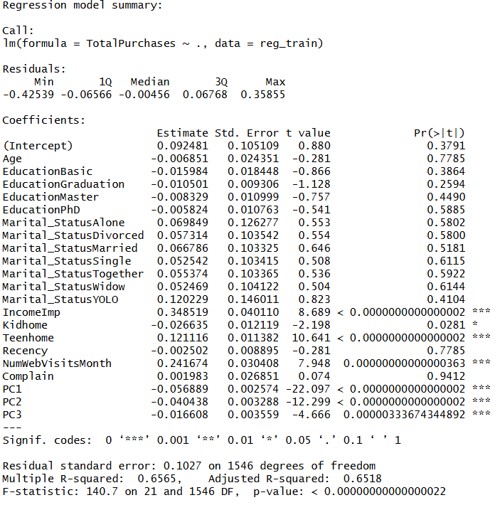
A stepwise regression model was then fitted. The final model included the variables IncomeImp, Kidhome, Teenhome, NumWebVisitsMonth, PC1, PC2, and PC3. The stepwise model produced an R-squared value of 0.6546 and adjusted R-squared of 0.6531. The residual standard error was 0.1025.
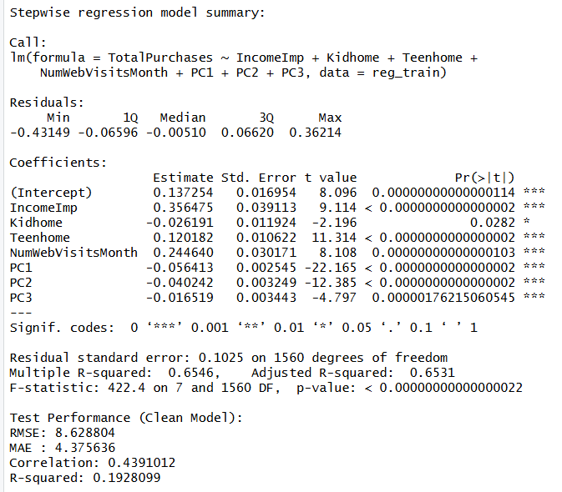
On the test dataset, the regression model produced:
RMSE: 8.628804
MAE: 4.375636
Correlation: 0.4391012
R-squared: 0.1928099
Classification Analysis:
The classification models were trained using a balanced dataset created using the ROSE technique.
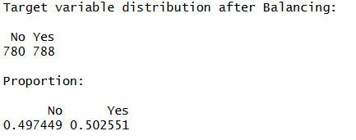
The logistic regression model was fitted and evaluated on the test dataset. The confusion matrix results were:
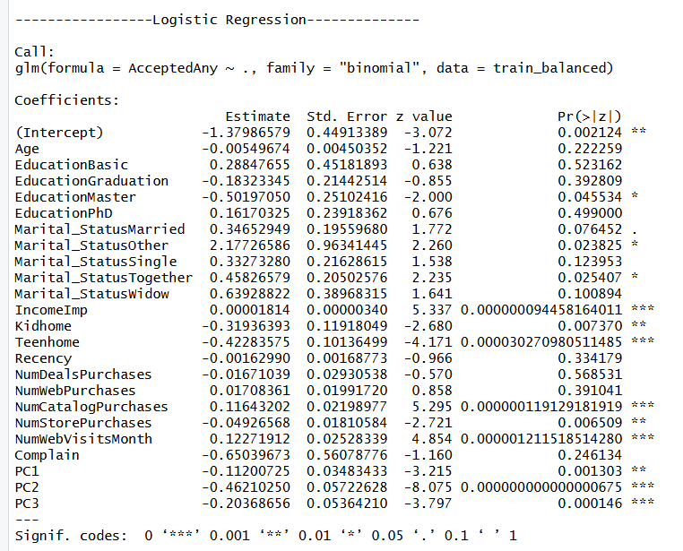
Accuracy: 0.744
Sensitivity: 0.7063
Specificity: 0.7543
Balanced Accuracy: 0.7303
AUC: 0.7762502
The decision tree model was fitted and evaluated on the test dataset. The confusion matrix results were:
Accuracy: 0.747
Sensitivity: 0.6923
Specificity: 0.7618
Balanced Accuracy: 0.7271
AUC: 0.7333668
The random forest model was fitted with 500 trees. The out-of-bag error rate was 25.45%. The confusion matrix results on the test dataset were:
Accuracy: 0.753
Sensitivity: 0.6643
Specificity: 0.7769
Balanced Accuracy: 0.7206
AUC: 0.781148
The tuned random forest model was fitted using cross-validation. The confusion matrix results on the test dataset were:
Accuracy: 0.7619
Sensitivity: 0.6783
Specificity: 0.7845
Balanced Accuracy: 0.7314
AUC: 0.777506

Report on models’ performance
This section reports the performance of all models implemented in the analysis and compares them to identify which models are most effective for supporting business decisions such as customer segmentation, engagement improvement, and campaign targeting.
Clustering Model Performance
The clustering process started with identifying the optimal number of clusters using the elbow method. The within-cluster sum of squares (WSS) was calculated for values of k from 2 to 10. The WSS reduced significantly from 228.8 billion at k = 2 to 87.26 billion at k = 4, after which the rate of decrease slowed down. This indicates that k = 4 is the optimal number of clusters, as adding more clusters does not provide significant improvement.
After selecting k = 4, the final K-means model was fitted on the training dataset. The clustering quality was evaluated using the silhouette score, which was 0.529, indicating moderate but acceptable separation between clusters. The clusters were also well distributed in size, with 360, 456, 267, and 485 customers in each cluster, ensuring meaningful segmentation.
Further validation showed strong statistical differences across clusters. ANOVA results confirmed that income varies significantly between clusters (F = 3756, p-value < 0.05). Chi-square tests also showed significant relationships between clusters and education (X² = 174.42) and between clusters and campaign response (X² = 207.6).
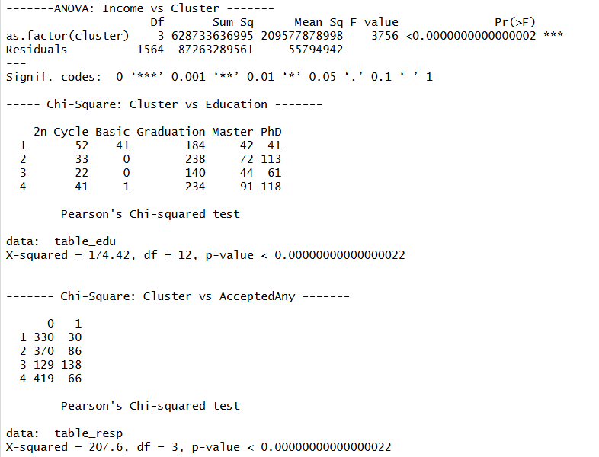
Most importantly, clusters showed clear differences in campaign response rates. One cluster had a very high response rate of 51.7%, while others had lower rates such as 8.3%, 18.9%, and 13.6%. This indicates that the clustering model is effective in identifying high-value and high-response customer segments, making it highly useful for targeted marketing strategies.
Association Model Performance
The Apriori model was first applied to the dataset with a minimum support of 1% and confidence of 30%. This resulted in 5,325 rules, capturing a wide range of relationships between customer behavior and campaign acceptance . However, many of these rules were complex and difficult to interpret.
To improve usefulness, the rules were filtered by adjusting the parameters to a minimum support of 0.5% and confidence of 20%, and by focusing on meaningful combinations of purchase behavior and campaign outcomes. This resulted in 26 strong and interpretable rules.
The performance of these rules was evaluated using support, confidence, and lift. For example, the rule {Web Buyer = Yes, Catalog Buyer = Yes} → {AcceptedAny = Yes} had a support of 0.164, confidence of 32.29%, and lift of 1.58. This means that customers using both web and catalog channels are significantly more likely to accept campaigns compared to the average customer.
Other rules involving product purchases such as wine and catalog buying also showed confidence values above 30% and lift greater than 1, indicating strong positive associations. These results show that the Apriori model effectively identifies behavioral patterns that can be directly used for campaign targeting.
Regression Model Performance
The regression analysis included both a full model and a refined stepwise model. The full regression model achieved an R-squared value of 0.6565 on the training dataset, indicating that approximately 65% of the variation in TotalPurchases is explained by the model . Many variables, including income, household composition, and PCA components, were statistically significant.
The stepwise regression model simplified the model by retaining only key predictors such as IncomeImp, Kidhome, Teenhome, NumWebVisitsMonth, and PCA components. The performance remained similar, with an R-squared of 0.6546, showing that the simplified model maintains strong explanatory power while improving interpretability.
However, when evaluated on the test dataset, the model showed reduced performance. The RMSE was 8.63 and MAE was 4.38, with a test R-squared of approximately 0.19. This indicates that while the model explains patterns well in training data, its predictive accuracy on new data is moderate. The goal is understand the factors influence consumer transaction activity rather than predicting the total purchases which is achieved.
Classification Model Performance
Multiple classification models were implemented and compared to identify the best model for predicting campaign response.
The logistic regression model achieved an accuracy of 74.4% and an AUC of 0.776. It also showed balanced performance with sensitivity of 70.63% and specificity of 75.43%. This model provides a good balance between predictive performance and interpretability.
The decision tree model achieved a slightly higher accuracy of 74.7% but a lower AUC of 0.733. The sensitivity was 69.23% and specificity was 76.18%. While the predictive performance is slightly lower, the model is useful for generating clear decision rules.
The random forest model improved predictive performance further, achieving an accuracy of 75.3% and the highest AUC of 0.781. It also showed strong specificity of 77.69%, indicating better identification of non-responders. The model’s out-of-bag error rate was approximately 25.45%, confirming stable training performance.
The tuned random forest model provided the best overall performance. It achieved the highest accuracy of 76.19% and a balanced accuracy of 73.14%. The sensitivity improved to 67.83%, and specificity increased to 78.45%. The AUC was 0.778, which is comparable to the base random forest model but with improved balance between correctly identifying responders and non-responders.
Overall Model Comparison
Across all models, different approaches serve different purposes. The clustering model is highly effective for identifying customer segments and shows strong differences in response behavior, making it valuable for segmentation strategies. The association model provides clear behavioral rules that help in understanding which combinations of actions lead to higher campaign success.
The regression model performs well in explaining customer engagement but has moderate predictive performance on new data, making it more useful for understanding key drivers rather than precise prediction.
Among classification models, the logistic regression model performs strongly with good accuracy and balanced sensitivity and specificity, providing consistent performance across both classes. It also achieves a good AUC , indicating good classification ability in distinguishing between responders and non-responders. While other models show slightly higher accuracy or AUC, the difference is marginal. Logistic regression offers a more stable and interpretable approach, making it suitable for predicting campaign response. Decision trees provide easy-to-understand rules, while more complex models capture interactions, but logistic regression maintains a strong balance between performance and simplicity.
Overall, combining these models provides a complete analytical approach, where clustering and association support segmentation and behavior understanding, and classification models support accurate prediction of campaign response.

Model evaluation (of the selected models)
This section provides a detailed evaluation of the selected models based on their performance and how effectively they support the analytical goal of predicting customer response and the business goal of improving campaign targeting.
Selected Model for Segmentation: K-means Clustering
The clustering model with 4 clusters is selected for segmentation as it shows clear separation in customer behavior and response patterns. The elbow method confirmed k = 4 as the optimal choice, and the silhouette score of 0.529 indicates acceptable cluster quality.
The clustering results show clear separation of customers across key variables such as income, purchasing behavior, household composition, and campaign response. From the PCA visualization, the clusters are reasonably well separated along the first principal component, with Cluster 3 positioned on the lower side of PC1, indicating higher spending patterns, while Cluster 1 and Cluster 4 are positioned on the positive side, indicating relatively lower spending. Cluster 2 lies between these groups, showing moderate behavior. This spread confirms that the clustering model has grouped customers based on meaningful differences in underlying spending patterns.
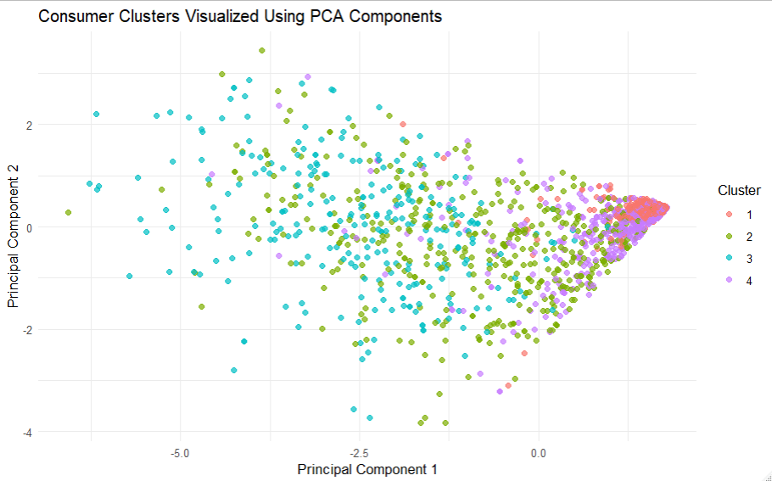

Income is one of the strongest differentiating variables across clusters. Cluster 3 has the highest average income (around 82,872), followed by Cluster 2 (63,424), Cluster 4 (43,559), and Cluster 1 with the lowest income (24,086). This pattern is also visible in the income distribution plot, where Cluster 3 shows a higher range and variability in income, while Cluster 1 is concentrated at the lower end. This income difference is reflected in purchasing behavior, where Cluster 3 customers have the highest number of catalog purchases (6.22) and store purchases (8.21), along with lower web visits (2.75), indicating more efficient and targeted purchasing. In contrast, Cluster 1 customers have very low catalog purchases (0.39) and web purchases (1.96), but higher web visits (7.09), indicating lower conversion despite higher browsing activity.
Household composition also varies across clusters. Cluster 1 has the highest proportion of customers with kids (Kidhome = 0.775), while Cluster 3 has the lowest (0.082), indicating that high-income customers are less likely to have children at home. Cluster 2 and Cluster 4 show higher Teenhome values (around 0.71 and 0.68), suggesting families with older children. These differences influence purchasing patterns, where households with children tend to have more deal-based purchases, as seen in Cluster 2 and Cluster 4 with higher NumDealsPurchases values (2.80 and 2.87).
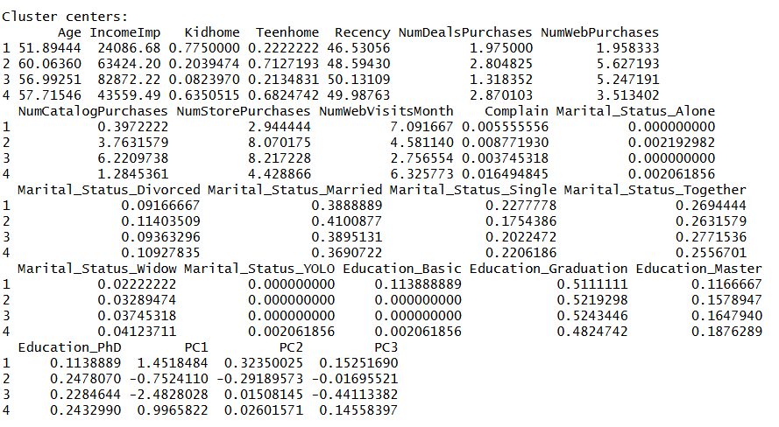
Campaign response behavior also differs significantly across clusters. Cluster 3 shows the highest overall campaign acceptance rate (51.7%), with strong acceptance across multiple campaigns such as cmp1 (26.2%) and cmp5 (33.7%). Cluster 2 shows moderate response (18.9%), while Cluster 4 (13.6%) and Cluster 1 (8.3%) have lower response rates. This indicates that high-income, high-spending customers (Cluster 3) are much more likely to respond to campaigns compared to low-income or lower-engagement groups.
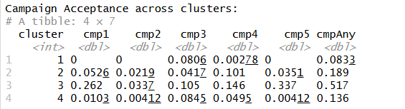

Overall, the clusters represent four distinct customer segments: low-income low-engagement customers (Cluster 1), moderate-income family-oriented customers (Cluster 2), high-income high-value customers (Cluster 3), and mid-income mixed-behavior customers (Cluster 4). These differences across variables show that customer behavior is strongly influenced by income, household structure, and purchasing habits, making the segmentation useful for targeted marketing strategies.
The evaluation shows that clusters differ significantly in key variables such as income and purchasing behavior, supported by ANOVA results with a very high F-value and extremely small p-value. Additionally, the chi-square test confirms a strong relationship between clusters and campaign response.
The most important observation is the variation in response rates across clusters. One cluster shows a response rate of approximately 51.7%, while others remain below 20%. This indicates that the model successfully identifies a high-response customer segment. From a business perspective, this allows focused targeting of high-probability customers instead of applying campaigns to the entire population.
Selected Model for Behavior Analysis: Apriori Association Model
The filtered Apriori model with 26 rules is selected for behavior analysis because it provides interpretable and actionable patterns. The rules show consistent relationships between purchase channels, product categories, and campaign acceptance.
The rules show the clear relation between purchase behavior and campaign acceptance. The best rules are based on purchase channels mainly web purchase behavior and catalog purchase behavior. The customers who use both web purchase behavior and catalog purchase behavior have the highest chance of campaign acceptance with the confidence and lift values of 32.29 and 1.58 respectively. In addition to this, customers who have purchased goods through catalog purchase behavior and store purchase behavior also have good campaign acceptance with confidence value of 32.05 and lift of 1.57. Catalog purchase behavior alone is sufficient to have good confidence value which is approximately 31.93%.
Product-based rules also follow similar trends, mainly when dealing with wines. The confidence and lift for clients who buy wines with catalog purchases are 31.97% and 1.56, respectively. When wine purchases are made together with web-based purchases, the confidence is relatively low but higher than the one observed during catalog-based purchases. This is an indication that wine purchasers tend to respond better to marketing strategies, especially when they are accompanied by other active channels. This trend is also confirmed by other product-based rules that deal with fruits, sweets, meats, and gold products, whose confidence ranges from 21% to 22%, while their lift value is slightly greater than 1.
It is also clear that individual purchasing activities like purchasing from a store alone or purchasing certain items alone are less reliable (confidence levels between 20-21%) and have lift factors near one. This indicates that being active through one channel or purchasing products from one category alone is less indicative of success during campaigns than using both activities together. It can be concluded from the above analysis that individuals who are more active through multiple channels and buy from multiple categories are more likely to respond to campaigns.
The evaluation shows that association rules capture combinations of behaviors rather than individual variables. This is important because campaign response can be influenced by multiple factors together. From a business perspective, these rules can be used to design targeted campaigns based on customer activity patterns, such as focusing on multi-channel buyers or specific product purchasers. These rules does not confirm causality but shows the relation between the variables which can help determine the customer's engagement patterns.
Evaluation of Regression Model
The regression model is evaluated for its ability to explain customer engagement through TotalPurchases. The model performs well on training data, with R-squared around 0.65, indicating strong explanatory power.
However, the test performance shows a lower R-squared of approximately 0.19, indicating that the model’s predictive accuracy on new data is limited. This suggests that while the model captures general trends, it is less reliable for precise prediction.
Despite this, the model is useful for identifying key drivers of customer engagement. Variables such as income, household composition, and web activity show strong influence on purchase behavior. From a business perspective, this helps in understanding what factors increase customer activity, even if the exact prediction is not highly accurate.
Selected Model for Prediction: Logistic Regression
In choosing the logistic regression model, the main criteria for making such a decision are high-quality performance together with the ability to be simple and clear in understanding. In particular, the model showed an accuracy of 74.4% and a balanced accuracy of 73.03%. These figures are very similar to those produced by other models. Additionally, the model has sensitivity of 70.63% and specificity of 75.43%, indicating that it can successfully detect both responders and non-responders.
Finally, the AUC equals to 0.776, suggesting that it is able to classify customers and show whether or not they have been responding to campaigns. This metric, among other indicators, is almost equal to more complex ones, while only being slightly worse concerning the accuracy.
The model also aligns well with findings from other analyses. The variables used in logistic regression capture patterns observed in clustering, where high-response segments were associated with higher income, higher purchasing activity, and lower web browsing frequency. Similarly, association analysis showed that customers engaging in multiple channels such as web and catalog have higher response rates, and these behavioral variables are included as predictors in the logistic model. The regression analysis identified income, household composition, and web activity as key drivers of customer engagement, and these same factors contribute to predicting campaign response in the logistic model.
This consistency across clustering, association, and regression strengthens the reliability of the logistic regression model. It confirms that the model is not only performing well statistically but is also aligned with observed customer behavior patterns. In addition, logistic regression provides clear insights into how each variable influences the probability of response, making it easier to translate analytical results into business actions.
Overall, logistic regression provides a strong balance between performance, interpretability, and alignment with other analytical findings, making it an effective model for predicting campaign response and supporting targeted marketing strategies.

Observation and conclusion
The analysis combined segmentation, behavior analysis, engagement modeling, and response prediction to understand customer behavior and support marketing decisions.
From the EDA, clear patterns were observed in customer demographics, spending, and purchasing behavior. Total spending across product categories showed that wine contributed the highest share, followed by meat products, indicating that these are the most important revenue-driving categories. Purchase channel analysis showed that store purchases were the highest, followed by web and catalog purchases, indicating that customers use multiple channels but still rely heavily on physical stores. Income-based analysis showed that customers in higher income groups had higher average spending and purchases, while lower income groups had lower engagement. Age group analysis showed variation in spending and response behavior across age segments. Campaign acceptance rates across individual campaigns were low, but when combined into the AcceptedAny variable, about 20% of customers had accepted at least one campaign, showing that responders are a smaller but important segment.
From the clustering analysis, customers were grouped into four distinct segments based on demographics, purchasing behavior, and engagement. These clusters showed clear differences in income, spending patterns, and campaign response. One cluster had a significantly higher response rate (around 51.7%) compared to others, indicating the presence of a high-value and highly responsive customer segment. This shows that customers are not homogeneous and need to be treated differently in marketing strategies.
The association analysis identified consistent patterns between customer behavior and campaign acceptance. Customers who use multiple purchase channels, especially web and catalog, showed a higher probability of accepting campaigns. Similarly, customers who purchase certain product categories such as wine and use catalog channels were more likely to respond. These patterns highlight that customer actions and preferences play an important role in campaign success.
The regression model showed that customer engagement, measured by total purchases, is influenced by factors such as income, household composition, and online activity. Customers with higher income and more web interactions tend to make more purchases, while the presence of children in the household affects purchasing behavior. Although the model’s predictive performance on new data was moderate, it clearly identifies the key factors that drive customer activity.
The classification models were used to predict campaign response. Among all models, the logistic regression model demonstrated strong performance with an accuracy of 74.4% and a balanced accuracy of 73.03%. It also showed good classification ability with an AUC of 0.776, indicating that the model can effectively distinguish between responders and non-responders. These results show that logistic regression can reliably identify customers who are more likely to respond to campaigns while maintaining consistent performance across both classes.
Overall, the analytics work directly supports the business goal of improving marketing effectiveness. The EDA provides an understanding of customer distribution, spending patterns, and campaign behavior. Clustering identifies high-response customer segments that can be targeted. Association analysis provides behavioral rules that can guide campaign design. The classification model helps in predicting which customers are most likely to respond, allowing prioritization of marketing efforts. The regression model identifies key factors that drive engagement, which can be used to increase customer activity.
By combining these models, the analysis provides a complete understanding of customer behavior. It helps in identifying the right customers, understanding their behavior patterns, and predicting their response. This supports data-driven decision making and enables more effective and targeted marketing strategies.

